# CS 340 README Template

## About the Project/Project Title

Simple Jupyter Dash app

This is a simple application using python, mongodb, and jupyter to create a filterable dashboard with some data visualization for an animal database.

## Motivation

This project was created as a project for Southern New Hampshire University. CS-340 focuses on Client/Server Development using Python and MongoDB.

## Getting Started

To set up the project you will need to configure the database values in the .ipynb file. Namely the username and password to match the database you have set locally. The dashboard assumes that you have a mongodb Database set up with the included .csv file. Once the database is set up and credentials are set correctly, you should just be able to run the jupyter notebook (see the video below).

## Installation

You will need to have Python (and additional libraries) , MongoDB, and Jupyter to run this application.

## Usage

### Example Video

[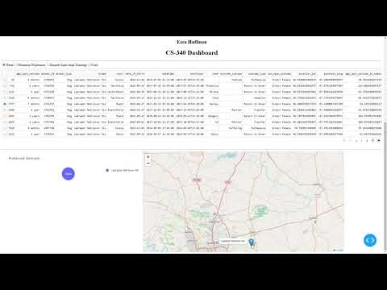](https://www.youtube.com/embed/2YqZKZHGJWo?feature=oembed)

## Contact

Your name: Ezra Huffman